More about SQL in action

Just as humans use different languages to communicate with others, so do computers. Structured Query Language (or SQL, often pronounced as “sequel”) lets data analysts talk to their databases. SQL is one of the most useful data analyst tools, especially when you are working with large datasets in tables. It can help you investigate huge databases, track down text (referred to as strings) and numbers, and filter for the exact kind of data you need—much faster than a spreadsheet can. In this reading, we will go over the basics of using SQL and explore an example query to demonstrate how SQL works in action.

## Basic syntax for SQL

Every programming language, including SQL, has to follow a unique set of guidelines known as syntax. As soon as you enter your search criteria using the correct syntax, the query should start working to pull the information you have requested from the target database.

### What is a query?

A query is basically a request for data or information from a database. For example, ''Tell me how many comedy movies were made in 1985” or ''How many people live in Puerto Rico?'' When we query databases, we use SQL to communicate our question or request. Both the user and the database can always exchange information as long as you “speak” the same language.

### The foundation of every SQL query is the same:

* Use SELECT to choose the columns you want to return.
* Use FROM to choose the tables where the columns you want are located.
* Use WHERE to filter for certain information.

## Basic components of a query (and a few useful tips)

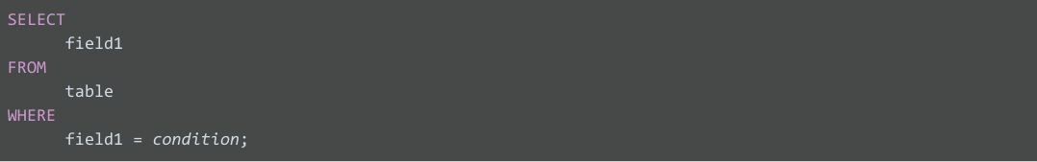

Tip 1: You can write your SQL queries all in lowercase and don’t have to worry about proper spacing between words. With that said, however, using capitalization and spacing can help you read the information more easily. Keep your queries neat, and they will be easier to review or troubleshoot if you need to check them later on.

In the SQL syntax shown above, the SELECT statement identifies the column you want to pull data from by name, field1, and the FROM statement identifies the table in which the column is located by name, table. Finally, the WHERE statement narrows your query so that the database returns only the data with an exact value match or the data that matches a certain condition that you want.

For example, if you are looking for a specific customer with the last name Chavez, the WHERE statement would be: WHERE field1 = 'Chavez';

However, if you are looking for all customers with a last name that begins with the letters “Ch”, the WHERE statement would be: WHERE field1 LIKE 'Ch%';

You can see that the LIKE statement is very powerful because it allows you to tell the database to look for a certain pattern! The percent sign (%) is used as a wildcard to match one or more characters. In our example, both Chavez and Chen would be returned. Note that in some databases the asterisk (*) is used as the wildcard instead of the percent sign (%).

### Can you use SELECT * ?

In our example, if you replace SELECT field1 with SELECT * you would be selecting all the columns in the table. From a syntax point of view, it is a correct SQL statement, but you should use it sparingly and with caution because depending on how many columns a table has, you could be selecting a tremendous amount of data.

Finally, you will notice that we have shown the SQL statement with a semicolon at the end. The semicolon is a statement terminator and is part of the American National Standards Institute (ANSI) SQL-92 standard which is a recommended common syntax for adoption by all SQL databases. However, not all SQL databases have adopted or enforce the semicolon, so it’s possible you may come across some SQL statements that aren’t terminated with a semicolon. If a statement works without a semicolon, it’s fine.

Tip 2: Some tables aren’t designed with descriptive enough naming conventions. In our previous example, field1 was the column for a customer’s last name, but you wouldn’t know it by the name. A better name would have been something like last_name. In these cases, you can place comments alongside your SQL statements to help you remember what the name represents. Comments are text placed between certain characters, /* and */, or after two dashes (--) as shown below.



Tip 3: You can also make it easier on yourself by assigning a new name or alias to the column or table names to make them easier to work with (and avoid the need for comments). This is done with a SQL AS statement. In the example below, you are changing field1 to last_name and table to customers for the duration of the query only. It doesn’t change the names in the actual table used in the database.

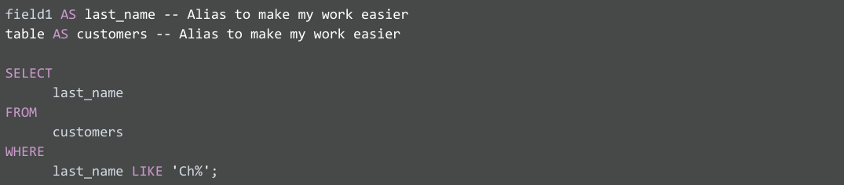

### Putting SQL to work (what you might do as a data analyst)

Imagine you are a data analyst for a small business and your manager asks you for some employee data. You decide to write a query with SQL to get what you need from the database.

Let’s say you want to pull all the columns: empID, firstName, lastName, jobCode, and salary. Because you know the database isn’t that big, instead of creating a SELECT statement for each column, you use SELECT *. This will select all the columns from the Employee table in the FROM statement.



Now, let’s get more specific about the data we want from the Employee table. If you want all the data about employees working in the SFI job code, you can use a WHERE statement to filter out the data based on this additional requirement.

Here, you use:

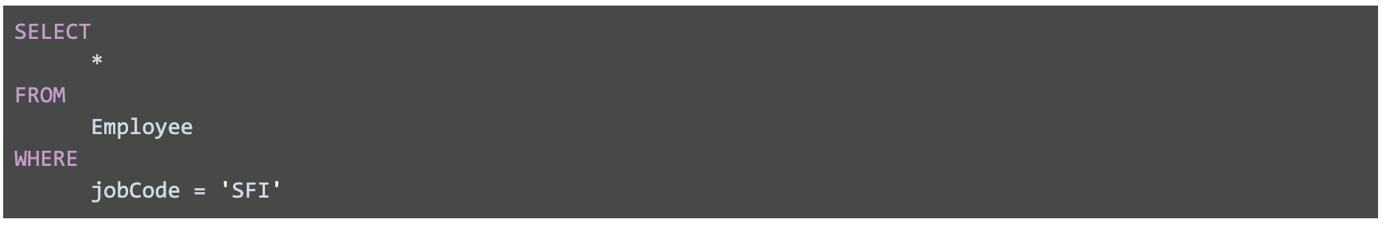

The portion of the resulting data returned from the SQL query might look like this:

|  |  |  |  |  |
| --- | --- | --- | --- | --- |
| **empID** | **firstName** | **lastName** | **jobCode** | **salary** |
| 0002 | Homer | Simpson | SFI | 15000 |
| 0003 | Marge | Simpson | SFI | 30000 |
| 0034 | Bart | Simpson | SFI | 25000 |
| 0067 | Lisa | Simpson | SFI | 38000 |
| 0088 | Ned | Flanders | SFI | 42000 |
| 0076 | Barney | Gumble | SFI | 32000 |

Suppose you notice a large salary range for the SFI job code, so you would like to flag all employees in all departments with lower salaries for your manager. Because interns are also included in the table and they have salaries less than $30,000, you want to make sure your results give you only the full time employees with salaries that are $30,000 or less. In other words, you want to exclude interns with the INT job code who earn less than $30,000. A SQL AND statement will enable you to find this information.

You create a SQL query similar to below, where <> means "does not equal":



The resulting data from the SQL query might look like the following (interns with the job code INT aren't returned):

|  |  |  |  |  |
| --- | --- | --- | --- | --- |
| **empID** | **firstName** | **lastName** | **jobCode** | **salary** |
| 0002 | Homer | Simpson | SFI | 15000 |
| 0003 | Marge | Simpson | SFI | 30000 |
| 0034 | Bart | Simpson | SFI | 25000 |
| 0108 | Edna | Krabappel | TUL | 18000 |
| 0099 | Moe | Szyslak | ANA | 28000 |

With quick access to this kind of data using SQL, you can provide your manager with tons of different insights about employee data, including whether employee salaries across the business are equitable. Fortunately, the query shows only an additional two employees might need a salary adjustment and you share the results with your manager.

Pulling the data, analyzing it, and implementing a solution might ultimately help improve employee satisfaction and loyalty. That makes SQL a pretty powerful tool.

## Resources to learn more

Non-subscribers may access these resources for free, but if a site limits the number of free articles per month and you already reached your limit, bookmark the resource and come back to it later.

* [SQL Cheat Sheet](https://towardsdatascience.com/sql-cheat-sheet-776f8e3189fa): This starter guide for standard SQL syntax used in PostgreSQL offers videos, activities, and readings on SQL. By the time you are finished, you will get to know a lot more about SQL and be prepared to use it for business analysis and other tasks.
* [W3Schools SQL Tutorial](https://www.w3schools.com/sql/default.asp): If you would like to explore a detailed tutorial of SQL, this is the perfect place to start. This tutorial includes interactive examples you can edit, test, and recreate. Use it as a reference or complete the whole tutorial to practice using SQL. Click the green Start learning SQL now button or the Next button to begin the tutorial.